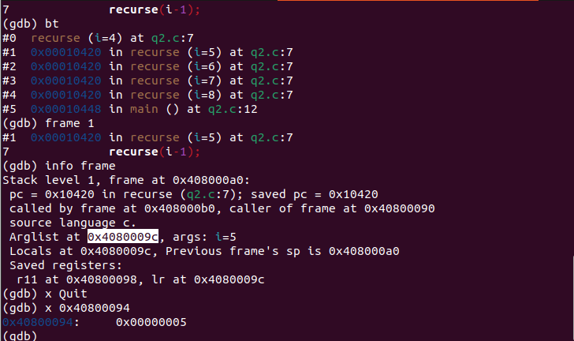
CS23B2004
Tarun Mamillapalli
Q1) The local variable is stored at the memory location 0x40800094.

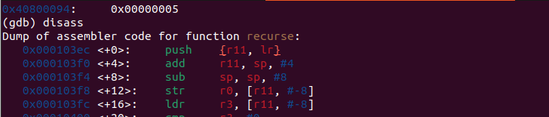
Q2) For the local variables in each frame, we use a total of 16 bytes, it is evident in the instruction 1 and 3.

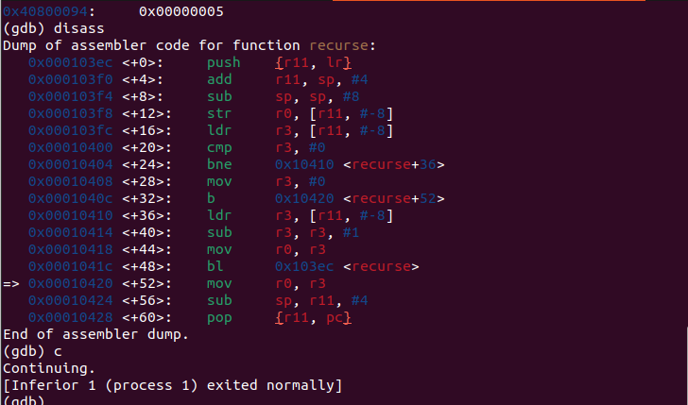
Q3) So, since the assembly code has the statement cmp r3,#0 the register r3 holds the argument list variable i, in the end there is a statement mov ro,r3, hence it is the r0 register that holds the return value.
Q4) We can take an character array of size, so that the stack allocated for each frame is increased by
40 bytes.

#include<stdio.h>
int recurse(int i)
{
char a[40];
if(i==0)
return 0;
else
recurse(i-1);
}
int main()
{
int i = 8;
recurse(i);
return 0;
}

